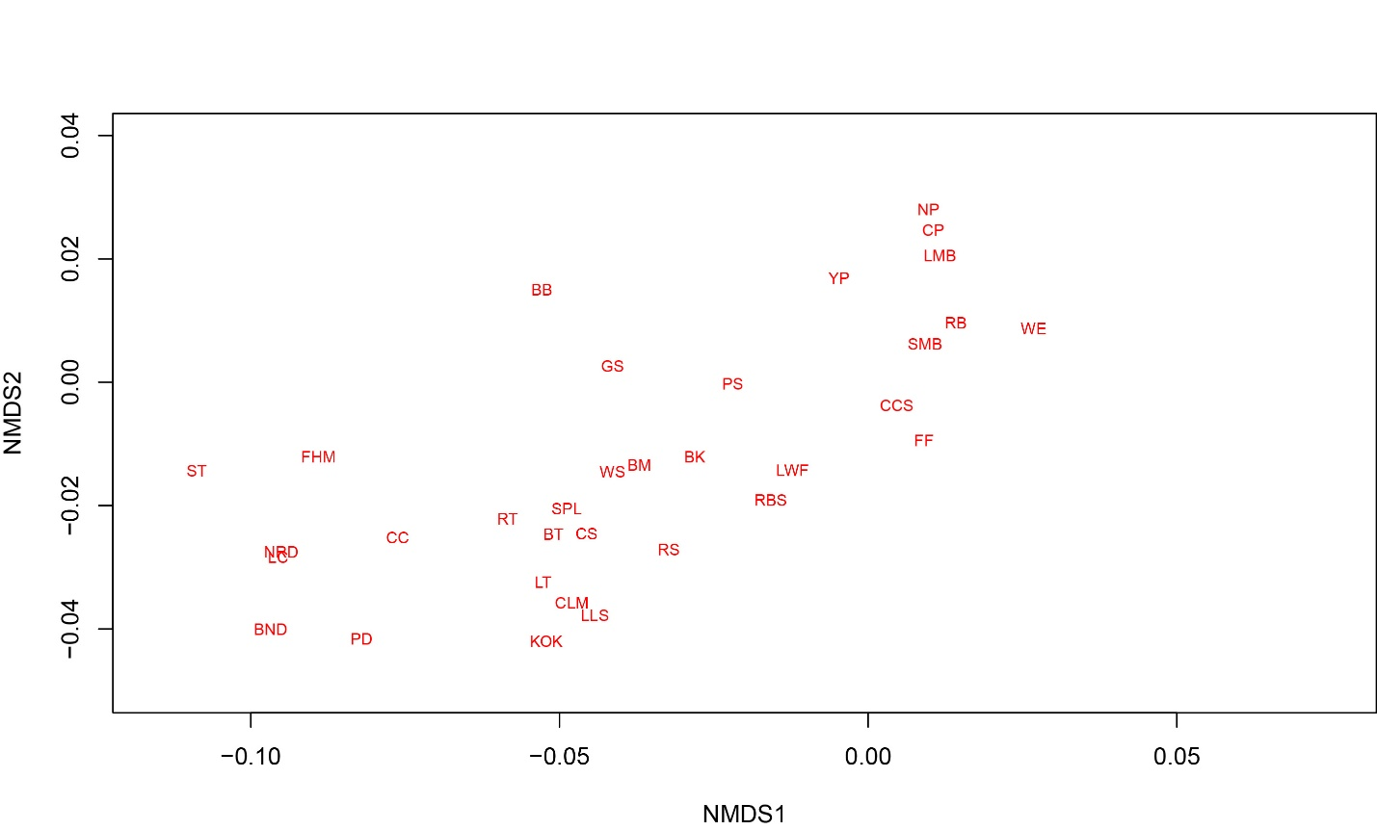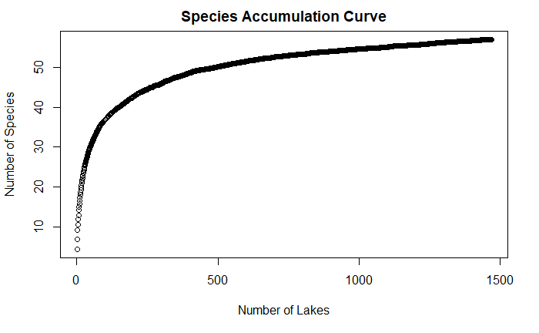

Simulation using data from ALSC database (n=100 simulations). Lakes were randomly ordered 100 times to reduce sampling location bias, species were counted to see how they accumulate. Number of lakes =1468. Max number of species = 57.

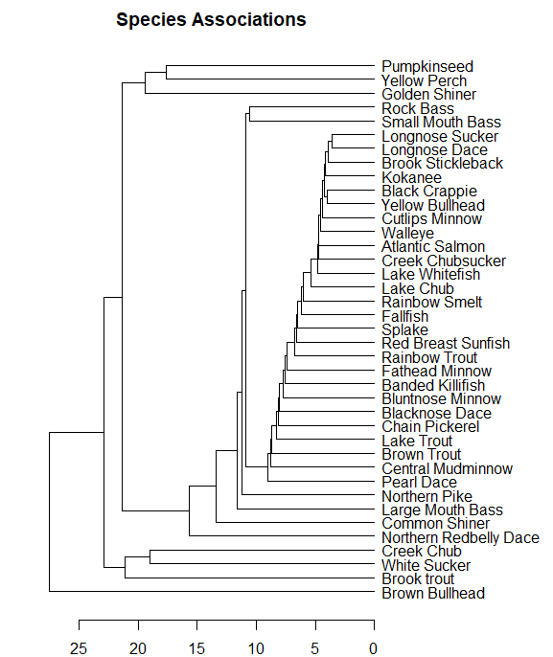

A dendrogram created using species with more than five lake occurrences. Method is average based on that pategonian fish paper. Euclidian distances. Need to change the acronyms to say the scientific/common names so its easier to understand

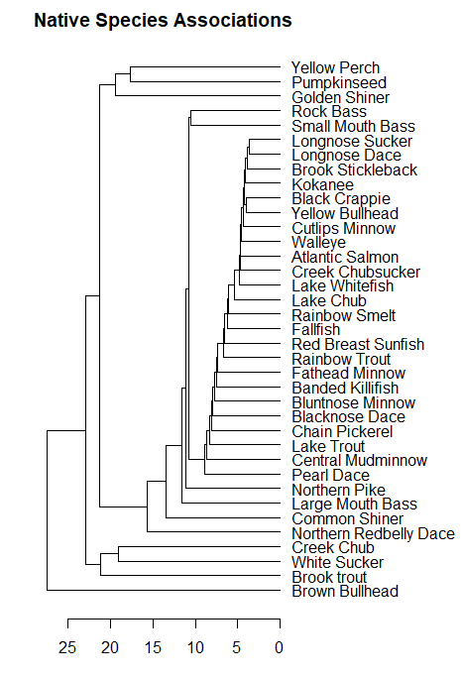

This includes all species that are A, I, or L – occur throughout the Adirondacks blue line. I have been introduced into other parts of the park, namely the high elevation. Excludes E (entirely exotic to the park) and species with less than five occurrences throughout all lakes sampled

* These are older methods try finding something like nmds to do similar analysis

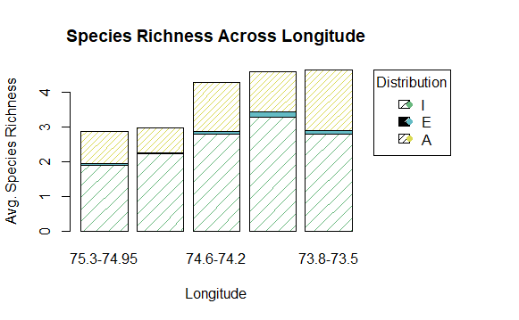 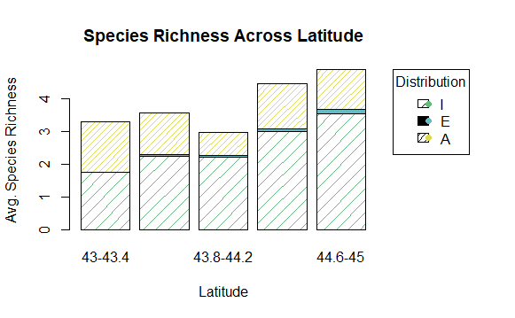

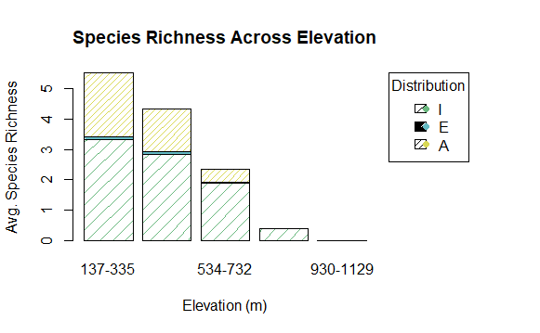

Components to the Baigun and Ferriz paper: Distribution patterns of native freshwater fishes n Patagonia (Argentina)

* Abstract
* Introduction – detaling concern for conservation status of native species. Notes that analyses should represent an effort to understand gaps in knowledge where we should be investing our research efforts
  + Study area
  + Fish community (including native and non-native information)
    - Table 1 is information on order, family, scientific name, and status (exotic, transplanted, native)
* Material and Methods –
  + Methods used in collecting the fish assemblage data
  + Information on the stats they did to understand the fauna and their relationships
    - Average-linkage cluster analysis and the Sorensen similarity index, which doubles weight for co-occurrences
* Results-
  + Latitude vs. species richness bar chart
  + Dendrogram of species assemblage

Intercontinental Comparison of small-lake fish assemblages: The Balance between Local and Regional Processes: Tonn et al., 1990 The American Naturalist

* “The idea that local and contemporary processes (e.g. interspecific interactions), combined with such regional and historical processes as immigration and extinction, should produce predictable patterns of community organization rekindled interest in questions concerning community similarity and convergence.”
* Analyses:
  + Species richness
    - – regional faunas defined by areas bounded by lakes within data sets
      * A regional fauna would include only species that maintain populations in small forest lakes
    - Proportions of regional faunas composing small lakes were used to measure habitat specialization by fishes.
      * Proportions compared between regions via the z-test (Johnson 1973)
    - Accumulation of species curves using random sampling without replacement
      * Rate of increase was used as an index of Whittakers beta diversity – asymptotic number of species expected in an infinite number of small lakes
    - Local richness – richness per single lake compared across regions and lake features
  + Species distributions –
    - Analyzed distribution patterns, using occurrence-sequence methods (Schoener and Schoener 1983)
      * Raked lakes along sequence of increasing value for each environmental factor (pH, area, isolation, conductivity, max depth)
        + Analyzed patterns of occurrence of species along ordered and haphazard distributions using Mann-Whitney U tests.
        + If presence or absence related to environmental variable, then species distribution should be concentrated at one end of the environmental spectrum

No pattern-would occur randomly across it

Limit to >5lakes

* + - To examine species pairs throughout the community – effects of interspecific interactions in regions: looked at patterns of species-cooccurrence
      * 2X2 contingency tables and fisher’s exact test to assess positive or negative associations between pairs of species
        + Can’t be used to test null that they are distributed independently, because stat independent assumptions violated.
        + But you can classify co-occurrences into three groups

Positive associations p<.05

Pairs have negative associations p<.05

Or either direction with p>.05

* + Assemblage composition: multivariate community analysis method of ordination and classification – they used a PCA on a correlation matrix